Jacob Andrews Portfolio Design

Andrews,Jacob
2026
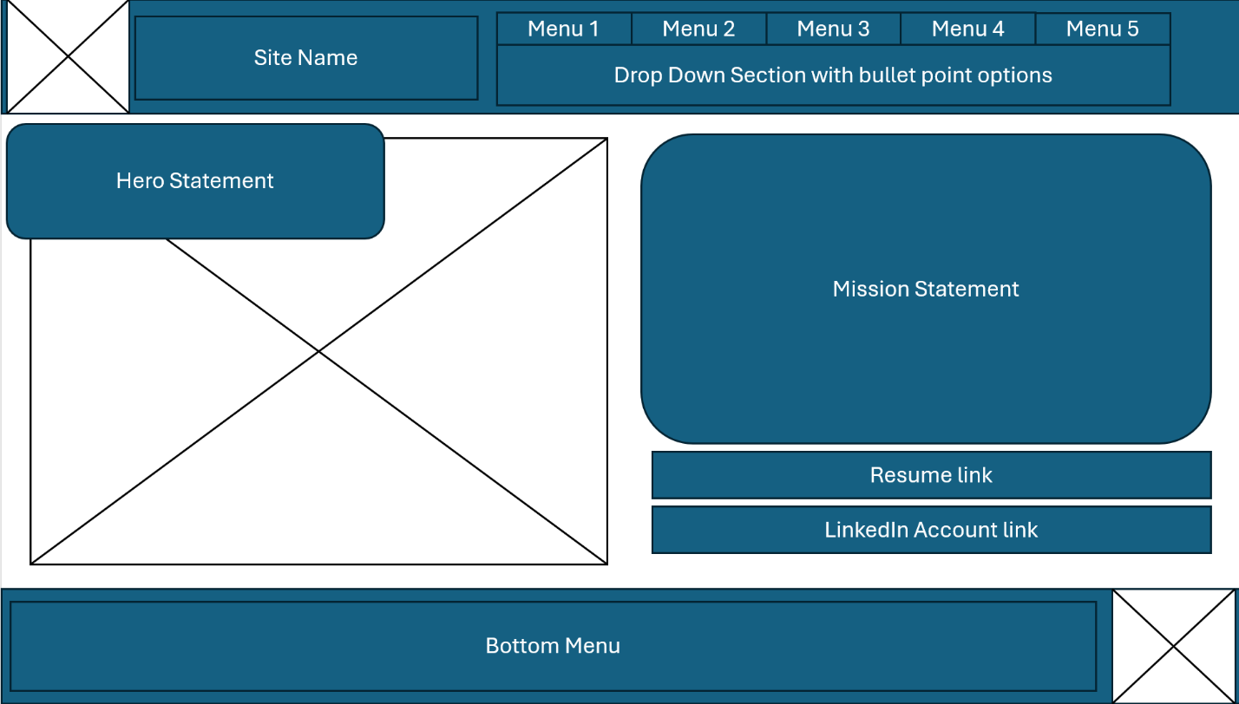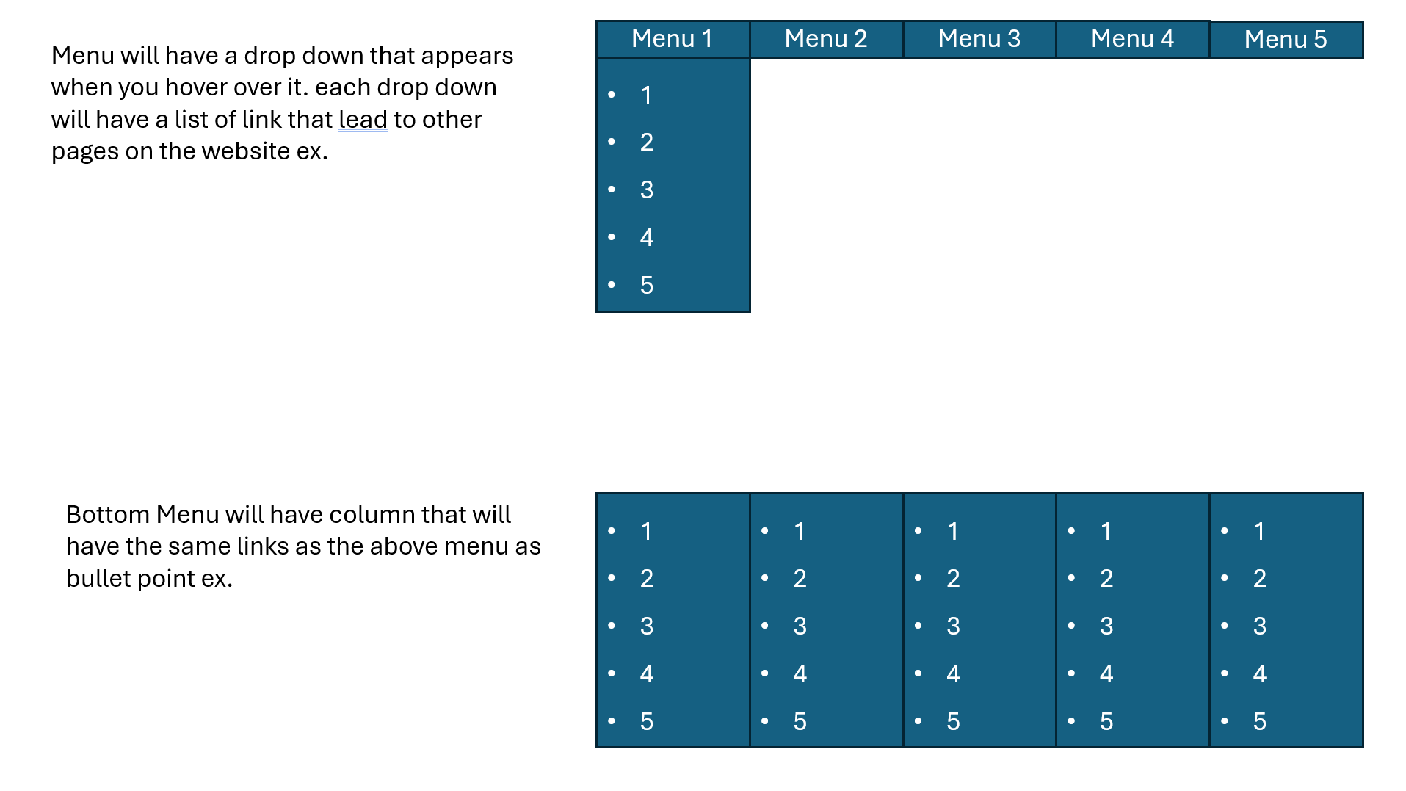
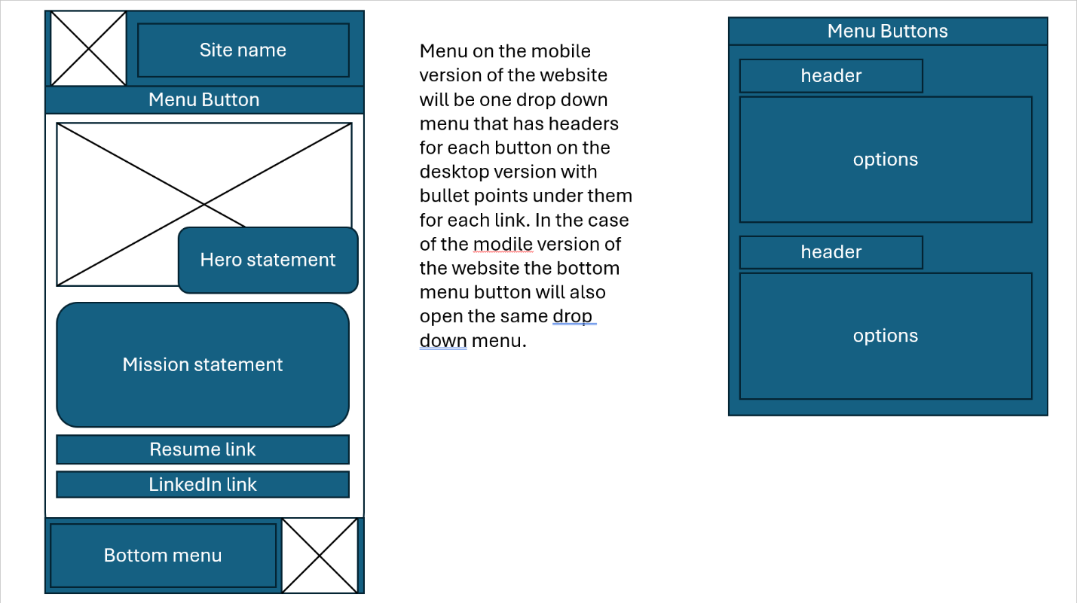

Write at least 100 words on how your thinking about your site might have changed between the wireframe stage and the build stage.
• What changes did you make in your design between wireframe and build?
• Why did you make them?
• What did you learn from this process?

Reflection after assignment 9:

I’ve changed multiple things about my website since the wire framing stage. A lot of the things I’ve changed because I was initially designing the wireframe more focused on the desktop version; however, I’ve now come to realize that making the layout more mobile-friendly is easier than my wireframe design where I was basically building two completely different layouts for different screen sizes. Some changes, for example, I was originally planning on using multiple hamburger menus for my nav bar. I’ve since decided that my website doesn’t have enough pages or sections to need them. My chosen colours have also changed as I’m trying to make the website a bit darker to be less straining on my eyes.

Doing these assignments since creating the wireframe have really taught me where my current skill level is and how even though you have an idea in the beginning, it’s important to be able to adapt and change to work with the situation as you find out what works and what doesn’t.

Well, I can’t say I’m fully satisfied with my current website layout and might even look around for some layout references for my final version; building this current version was still good practice.

Validation of Html
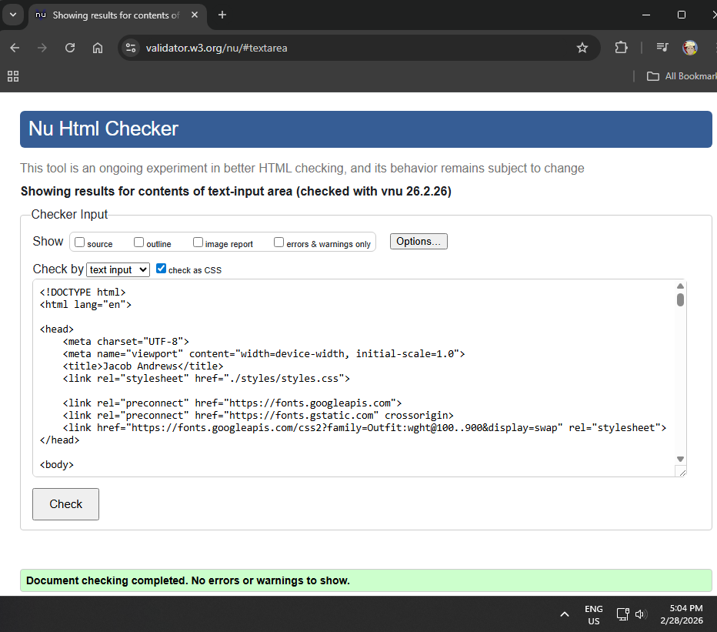

Validation of CSS
